Gardener F5 Application Load Balancer Extension
Part 2 - Component Architecture and Internal Desired-State Model
Architecture and Low-Level Design
Version 1.0 - Design Baseline
17 July 2026
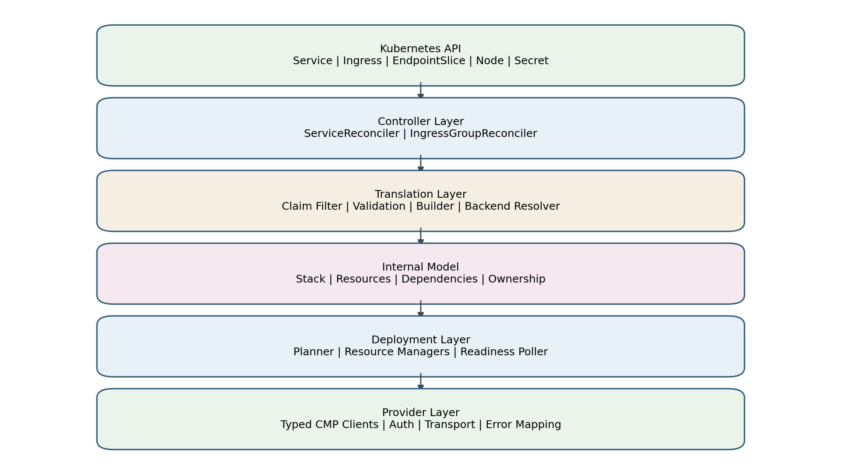
Figure 2-1. Target layered architecture

1. Purpose and Position in the Design Set
This part defines the internal architecture that translates Kubernetes networking intent into CMP/F5 resources. It follows Part 1, which established the architecture basis and provider capability mapping. This document fixes the component boundaries, internal resource model, dependency rules, ownership contract, backend-resolution contract, and package-level interfaces that Parts 3 through 7 will implement in detail.
The AWS Load Balancer Controller is used as an architectural reference, specifically for its thin reconcilers, dedicated model builders, stack-based desired state, resource-specific deployment managers, finalizer handling, and provider tracking. The design does not reproduce AWS-specific resources or behavior. CMP OpenAPI remains the authoritative provider capability contract. The existing Gardener F5 code is treated only as evidence for authentication, endpoint usage, request/response details, and integration constraints.

1.1 Fixed architectural outcome
Kubernetes objects
-> thin reconcilers
-> validation and backend resolution
-> typed desired-state stack
-> resource-specific deployment managers
-> typed CMP clients
-> CMP/F5
- Controllers do not construct CMP payloads.
- Builders do not mutate CMP.
- Deployment managers do not interpret Kubernetes annotations.
- CMP clients do not contain Kubernetes business rules.
- Every managed provider object carries verifiable ownership metadata.
- Correctness is based on reconciliation from durable Kubernetes and CMP state, never on controller memory.

1.2 Scope of Part 2
Included | Deferred to later parts
Component boundaries; desired/observed model; backend resolution; ownership; finalizer architecture; deployment orchestration; package design; Go interfaces | Service-specific semantics and algorithms - Part 3
Shared foundations for Service and Ingress | Ingress rules, grouping, TLS details - Part 4
Provider-manager contracts and readiness gates | Full endpoint-by-endpoint client behavior - Part 5
Representative reconciliation sequence | All runtime sequences and state machines - Part 6
Implementation slices and package acceptance criteria | Complete migration and test execution plan - Part 7

2. Architectural Evidence and Adaptation Rules

2.1 Patterns adopted from AWS Load Balancer Controller
AWS LBC pattern | Reason it is proven | F5/CMP adaptation
Separate Service reconciler and Ingress-group reconciler | Different Kubernetes ownership, events, grouping, status and deletion semantics | Keep independent controllers/builders; share model, deployer, resolver and clients
ModelBuilder.Build returns a complete stack | Provider operations are separated from Kubernetes interpretation | Build an F5 Stack with LBService, VIP, VirtualServers, Pools, Members, Monitors, Rules and Certificates
StackDeployer deploys resource graph | Resource ordering and provider reconciliation are centralized | CMP StackDeployer coordinates typed managers and asynchronous readiness
Resource-specific managers/synthesizers | Each provider resource has focused diff and lifecycle logic | LBServiceManager, VIPManager, VirtualServerManager, PoolManager, MemberManager, MonitorManager, RoutingRuleManager, CertificateManager
Finalizers around external-resource cleanup | Kubernetes object cannot vanish before cloud cleanup | Service finalizer and group-aware Ingress finalizers
Tracking metadata/tags | Safe discovery, adoption and deletion | CMP labels where supported plus deterministic ownership envelope
Event handlers map related-resource changes to owners | Endpoint, Service, Secret and class changes enqueue correct reconciliations | Explicit watch/index graph for Service and Ingress

2.2 Patterns not copied blindly
AWS-specific element | Decision
ELBv2 LoadBalancer/Listener/TargetGroup schemas | Replace with CMP LB Service/VIP/Virtual Server/Pool/Member schemas
Security-group synthesis | Not part of the core F5 object model; integrate only where Airtel network policy requires it
AWS subnet/VPC discovery rules | Use Gardener Shoot configuration and CMP network identifiers
AWS target registration modes | Initial target mode is node/VM plus NodePort because CMP members require VM/network identity
AWS tagging semantics | Use CMP labels/description fields and ownership verification compatible with Swagger
ALB listener action JSON | Translate Ingress routing semantics to CMP routing-rule API and default-pool operation

3. Target Component Architecture

Figure 2-2. Layered component architecture
Each layer owns one type of decision. Downward dependencies are permitted; upward dependencies are prohibited. Cross-layer shortcuts, such as a controller importing HTTP transport types or a CMP client reading Kubernetes annotations, are architecture violations.

3.1 Component inventory
Component | Primary responsibility | Must not do
Controller Manager | Wiring, leader election, health, metrics, configuration, client construction | Load-balancer business logic
ServiceReconciler | Claim Service, coordinate finalizer/build/deploy/status | Construct provider payloads
IngressGroupReconciler | Load group, coordinate group finalizers/build/deploy/status | Implement route translation itself
Claim Filter | Determine whether an object belongs to this controller | Mutate objects or provider state
Validator | Reject unsupported or inconsistent Kubernetes intent | Perform provider writes
Model Builder | Create complete deterministic desired-state graph | Read or mutate actual CMP state
Backend Resolver | Resolve endpoints/nodes to authoritative CMP identities | Invent resource IDs or backend_port_id
Stack Deployer | Order managers, maintain transaction context, aggregate result | Parse annotations
Resource Manager | Reconcile one resource type | Control unrelated resource types
Typed CMP Client | API paths, auth, encoding, decoding, errors, timeouts | Kubernetes reconciliation policy
Ownership Provider | Generate and verify ownership envelope | Infer ownership from name alone
Status Writer | Patch Service/Ingress status and expose stable observations | Provision provider resources

4. Controller Boundaries and Watch Graph
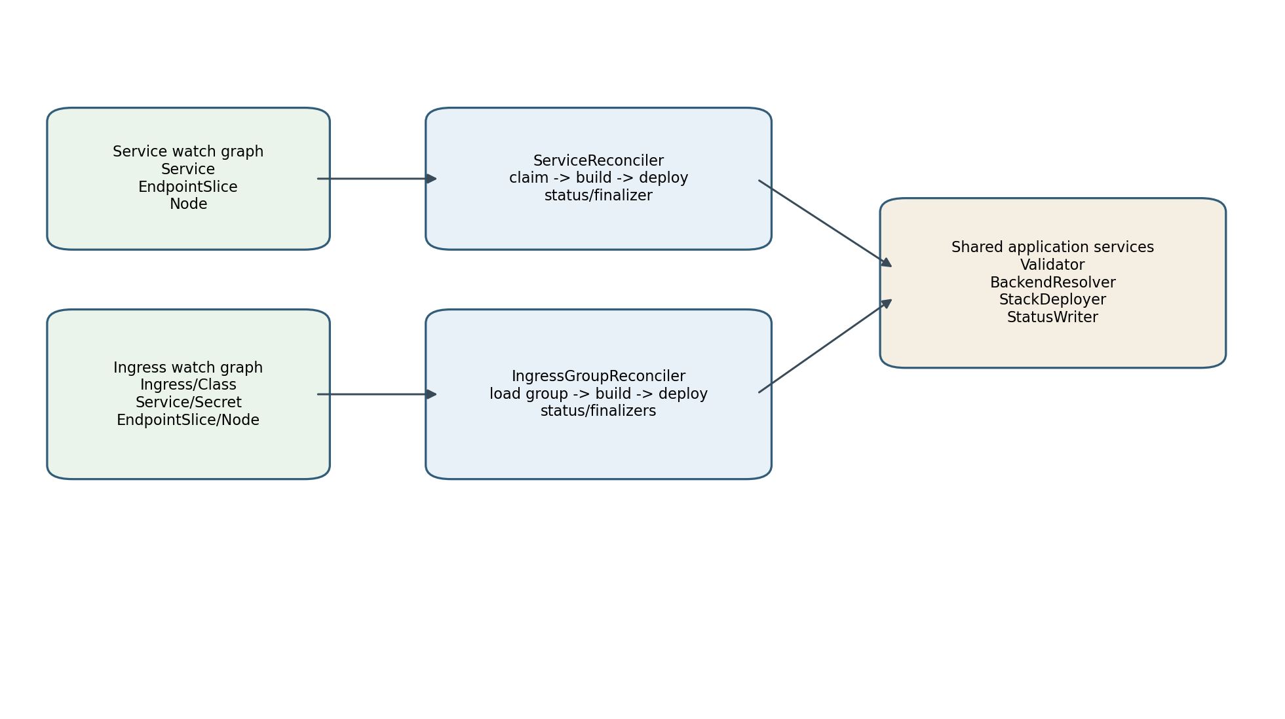
Figure 2-3. Controller boundaries and shared application services

4.1 Service controller contract
- Owns Service resources selected by loadBalancerClass and/or the supported compatibility claim rule.
- Watches Service directly and maps EndpointSlice and Node changes back to affected Services.
- Adds the Service finalizer before creating external resources.
- Builds exactly one logical stack per Service unless an explicit shared-frontend feature is enabled.
- Publishes Service.status.loadBalancer only after the selected readiness gate passes.

4.2 Ingress controller contract
- Owns Ingress resources selected through the F5 IngressClass.
- Reconciles an Ingress group rather than an isolated Ingress when grouping is enabled.
- Watches Ingress, IngressClass, IngressClassParameters if introduced, referenced Services, Secrets, EndpointSlices and Nodes.
- Builds one stack for the active group and treats inactive members as cleanup inputs.
- Uses group-aware finalizer management so a shared frontend is not deleted while active members remain.

4.3 Event-to-owner indexing
Event source | Service enqueue rule | Ingress enqueue rule
Service | self | Ingresses referencing Service
EndpointSlice | Service label kubernetes.io/service-name | Ingresses referencing owning Service
Node | all managed node-target Services, with debouncing/index optimization | all groups whose backends use node target mode
Ingress | none | group ID of Ingress
Secret | none | groups referencing TLS Secret
IngressClass | none | Ingresses using class

5. Reconciliation Pipeline
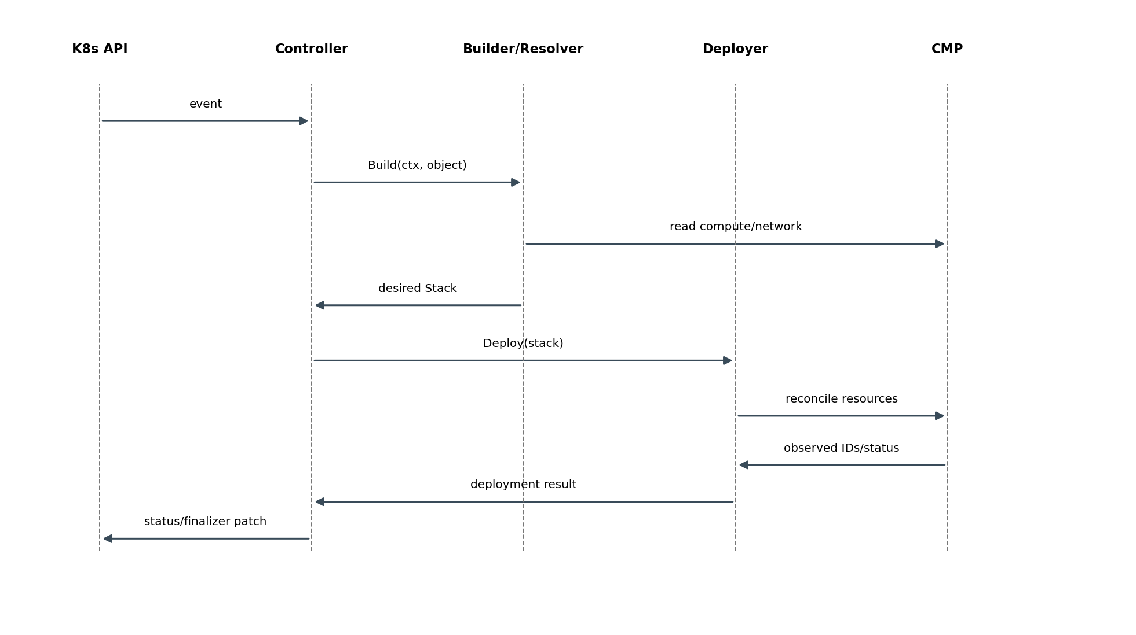
Figure 2-4. Representative reconciliation sequence

5.1 Common orchestration algorithm
1. Fetch the latest Kubernetes owner or group.
2. Evaluate claim/ownership.
3. If deleting or no longer claimed, build an empty desired stack and clean up owned CMP resources.
4. Validate configuration and provider capability constraints.
5. Add finalizer before first external create.
6. Resolve backends and supporting identities.
7. Build a complete deterministic desired stack.
8. Discover observed CMP inventory using ownership and stored IDs.
9. Produce and execute a dependency-ordered reconciliation plan.
10. Poll only resources whose API is asynchronous and whose readiness is required.
11. Patch Kubernetes status and emit events/metrics.
12. Remove finalizer only after required owned resources are absent.

5.2 Error ownership
Error source | Classification owner | Controller behavior
Unsupported Service/Ingress field combination | Validator | Permanent until object changes; Event; no fast retry
Node has no InternalIP | Backend Resolver | Dependency not ready; bounded requeue
CMP compute/network lookup timeout | CMP client + resolver | Retryable transport error
CMP 401/403 | CMP client | Authentication/authorization; slow retry and alert
CMP 409 during create | Resource manager | Rediscover and verify ownership/idempotency
CMP provisioning still in progress | Resource manager/readiness poller | RequeueAfter without treating as failure
Status patch conflict | Status writer | Refetch and retry patch

6. Internal Desired-State Model
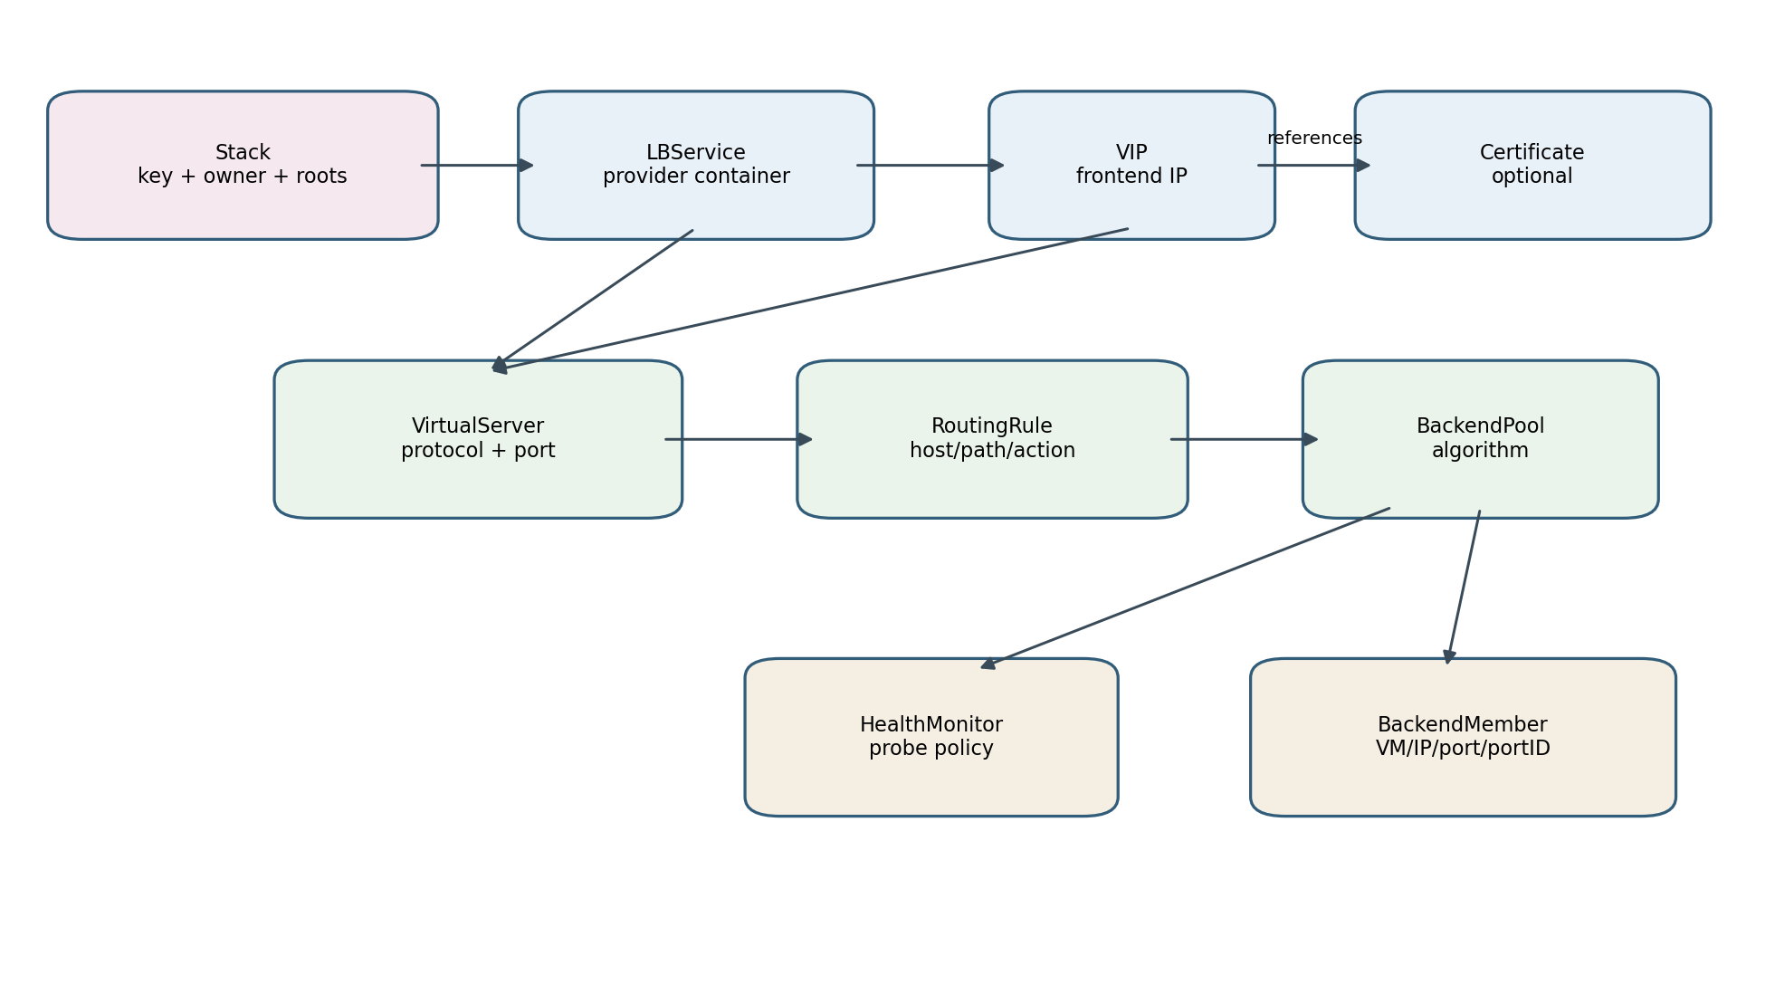
Figure 2-5. Internal desired-state resource graph
The internal model is an in-memory typed graph. It is not a CRD and is not persisted as a second source of truth. It captures the complete desired provider configuration for one reconciliation key and contains enough metadata for deterministic deployment and cleanup.

6.1 Core abstractions
Type | Purpose | Key invariants
Stack | Root graph, stack key, owner, resource registry and dependency edges | Stable key; no duplicate logical IDs; acyclic dependencies
ResourceMeta | Logical ID, external ID if observed, ownership, dependencies | Logical ID deterministic; external ID never fabricated
LBService | CMP service container and network/flavor context | Exactly one root per non-shared stack
VIP | Allocated or requested frontend address | References LBService; published only when ready
VirtualServer | Protocol/port frontend listener equivalent | Unique frontend tuple within stack
RoutingRule | Host/path match and pool action | Ordered deterministically; references existing pool
BackendPool | Backend group, balancing algorithm and default status | Unique per backend identity and routing semantics
HealthMonitor | Probe definition attached to pool | Protocol compatible with pool/backend
BackendMember | Authoritative target identity and service port | resource_id, resource_ip and backend_port_id resolved from CMP
Certificate | Certificate reference/attachment model | Secret material not placed in logs or logical IDs

6.2 Proposed Go model
type Stack struct {
Key StackKey
Owner Ownership
Resources ResourceRegistry
Edges []Dependency
}
type ResourceMeta struct {
LogicalID string
ExternalID string // observed only
Role ResourceRole
Ownership Ownership
DependsOn []string
}
type LBService struct { Meta ResourceMeta; Spec LBServiceSpec }
type VIP struct { Meta ResourceMeta; Spec VIPSpec }
type VirtualServer struct { Meta ResourceMeta; Spec VirtualServerSpec }
type BackendPool struct { Meta ResourceMeta; Spec BackendPoolSpec }
type BackendMember struct { Meta ResourceMeta; Spec BackendMemberSpec }

7. Resource Specifications and Identity

7.1 LBServiceSpec
Field | Source | Rule
Name | NamingProvider | Deterministic and CMP length-safe
Description | OwnershipProvider | Human-readable ownership envelope
FlavorID | Controller config / supported annotation | Validated against permitted flavor set
NetworkID | Shoot/provider config | Required and immutable unless replacement is explicitly supported
VPCID/VPCName | Shoot/provider config | Must match backend network context
Labels | OwnershipProvider | Canonical managed-by, cluster and source identity

7.2 VIPSpec
Field | Meaning
LBServiceRef | Logical reference to parent
RequestedAddress | Optional only if API and policy allow static address
AddressFamily | IPv4 initially; dual stack deferred until verified
Scheme/Visibility | Provider-supported visibility policy
Ownership | Inherited plus role=vip

7.3 VirtualServerSpec
Field | Meaning
VIPRef | Frontend address reference
Protocol | TCP/HTTP/HTTPS according to validated mapping
Port | Frontend service/listener port
Persistence | CMP-supported persistence policy
DefaultPoolRef | Pool used when no rule matches
CertificateRefs | TLS attachments
SourceCIDRs | Only if CMP endpoint supports equivalent semantics
ConnectionPolicy | Only supported CMP attributes

7.4 BackendPool and Member specifications
Type | Critical fields
BackendPoolSpec | VirtualServerRef, algorithm, default flag, monitor reference, backend key
BackendMemberSpec | resource_id, resource_type, resource_ip, backend_port_id, port, weight, administrative state
HealthMonitorSpec | type, interval, timeout, retries, HTTP path/expected response when supported

8. Logical IDs, Naming and Determinism
Logical IDs are controller-internal identities used to connect the graph and correlate desired and observed resources. Provider names are separately sanitized. Neither replaces provider external IDs returned by CMP.
Resource | Logical-ID input example
LB Service | clusterUID/sourceKind/sourceUID/sharedGroup
VIP | stackKey/frontend-address-family
Virtual Server | stackKey/protocol/frontendPort
Pool | stackKey/backendServiceUID/backendPort/routing-scope
Member | poolLogicalID/nodeUID/nodePort
Routing Rule | virtualServerLogicalID/host/path/pathType/priority
Monitor | poolLogicalID/monitor-fingerprint
logicalID = SHA256(canonical components) shortened only for display
providerName = sanitize(readable prefix + short hash)
externalID = value returned by CMP; never derived

9. Desired and Observed State Separation
Desired state | Observed state
Built exclusively from Kubernetes intent, controller configuration and authoritative identity resolution | Read from CMP APIs and Kubernetes status/annotations used solely as hints
Contains logical references | Contains external provider IDs and provisioning status
May request creation/update/deletion | Never directly changes desired semantics
Deterministic for same inputs | May be temporarily incomplete because CMP is asynchronous
The deployment layer compares normalized specifications, not raw JSON. Server-generated fields, timestamps, request IDs and provider defaults are removed or canonicalized before equality decisions.

9.1 Plan operations
Operation | Condition
Create | Desired resource exists; no owned observed resource
NoOp | Normalized desired equals observed and resource ready
Update | Mutable fields differ
Replace | Immutable field differs and safe replacement strategy exists
Delete | Owned observed resource absent from desired
Wait | Desired exists but dependency/provider resource is provisioning
Reject | Observed name matches but ownership does not

10. Dependency Graph and Ordering
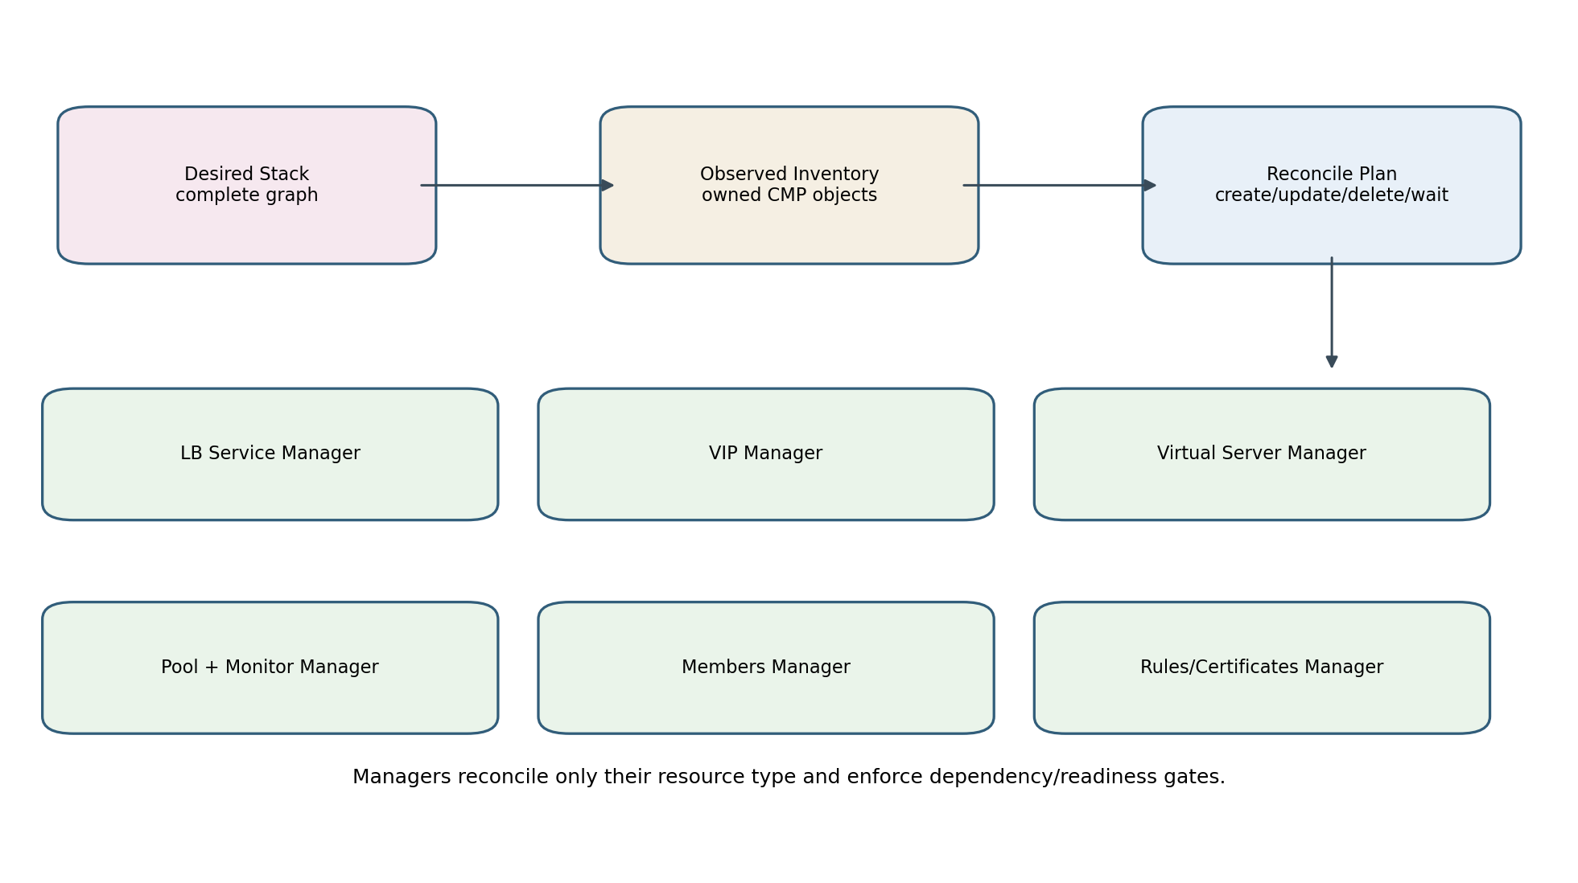
Figure 2-6. Deployment architecture and resource managers

10.1 Required creation dependencies
Resource | Required dependencies
LB Service | none
VIP | LB Service ready enough for VIP operation
Virtual Server | LB Service and VIP allocated/ready
Pool | Virtual Server exists
Health Monitor | Pool exists
Backend Member | Pool exists; node/VM/network identities resolved
Routing Rule | Virtual Server and referenced pool exist
Certificate attachment | LB Service/Virtual Server exists; certificate resource available

10.2 Deletion rules
Routing rules / certificate attachments
-> members and monitors
-> pools
-> virtual servers
-> VIP
-> LB service
The exact ordering is derived from CMP endpoint relationships. A manager may skip a delete that CMP performs transitively, but the controller must verify absence before finalizer removal. Shared roots are protected by reference/ownership checks.

11. Deployment Manager Contracts

11.1 StackDeployer
type StackDeployer interface {
Deploy(ctx context.Context, desired model.Stack) (DeploymentResult, error)
}
type DeploymentResult struct {
VIPs []ObservedVIP
Resources map[string]ObservedResource
Ready bool
RequeueAfter time.Duration
}
The deployer is an orchestrator. It obtains an owned inventory, asks each manager to reconcile its resource type in dependency order, maintains a logical-to-external ID binding map, and returns readiness/status observations. It does not understand Service or Ingress fields.

11.2 Generic manager contract
type ResourceManager[TDesired any, TObserved any] interface {
Discover(ctx context.Context, scope Scope, owner Ownership) ([]TObserved, error)
Reconcile(ctx context.Context, desired []TDesired, observed []TObserved, bindings Bindings) (ManagerResult, error)
}
Manager | CMP API family
LBServiceManager | .../load-balancers/lb_service
VIPManager | .../lb_service/{id}/vip
VirtualServerManager | .../{lb_service_id}/virtual-servers
PoolManager | .../virtual-servers/{vs_id}/pools
MemberManager | .../pools/{pool_id}/members
MonitorManager | .../pools/{pool_id}/monitors
RoutingRuleManager | .../virtual-servers/{vs_id}/routing-rules
CertificateManager | certificate APIs and LB/VS attachment APIs

12. Backend Resolution Architecture
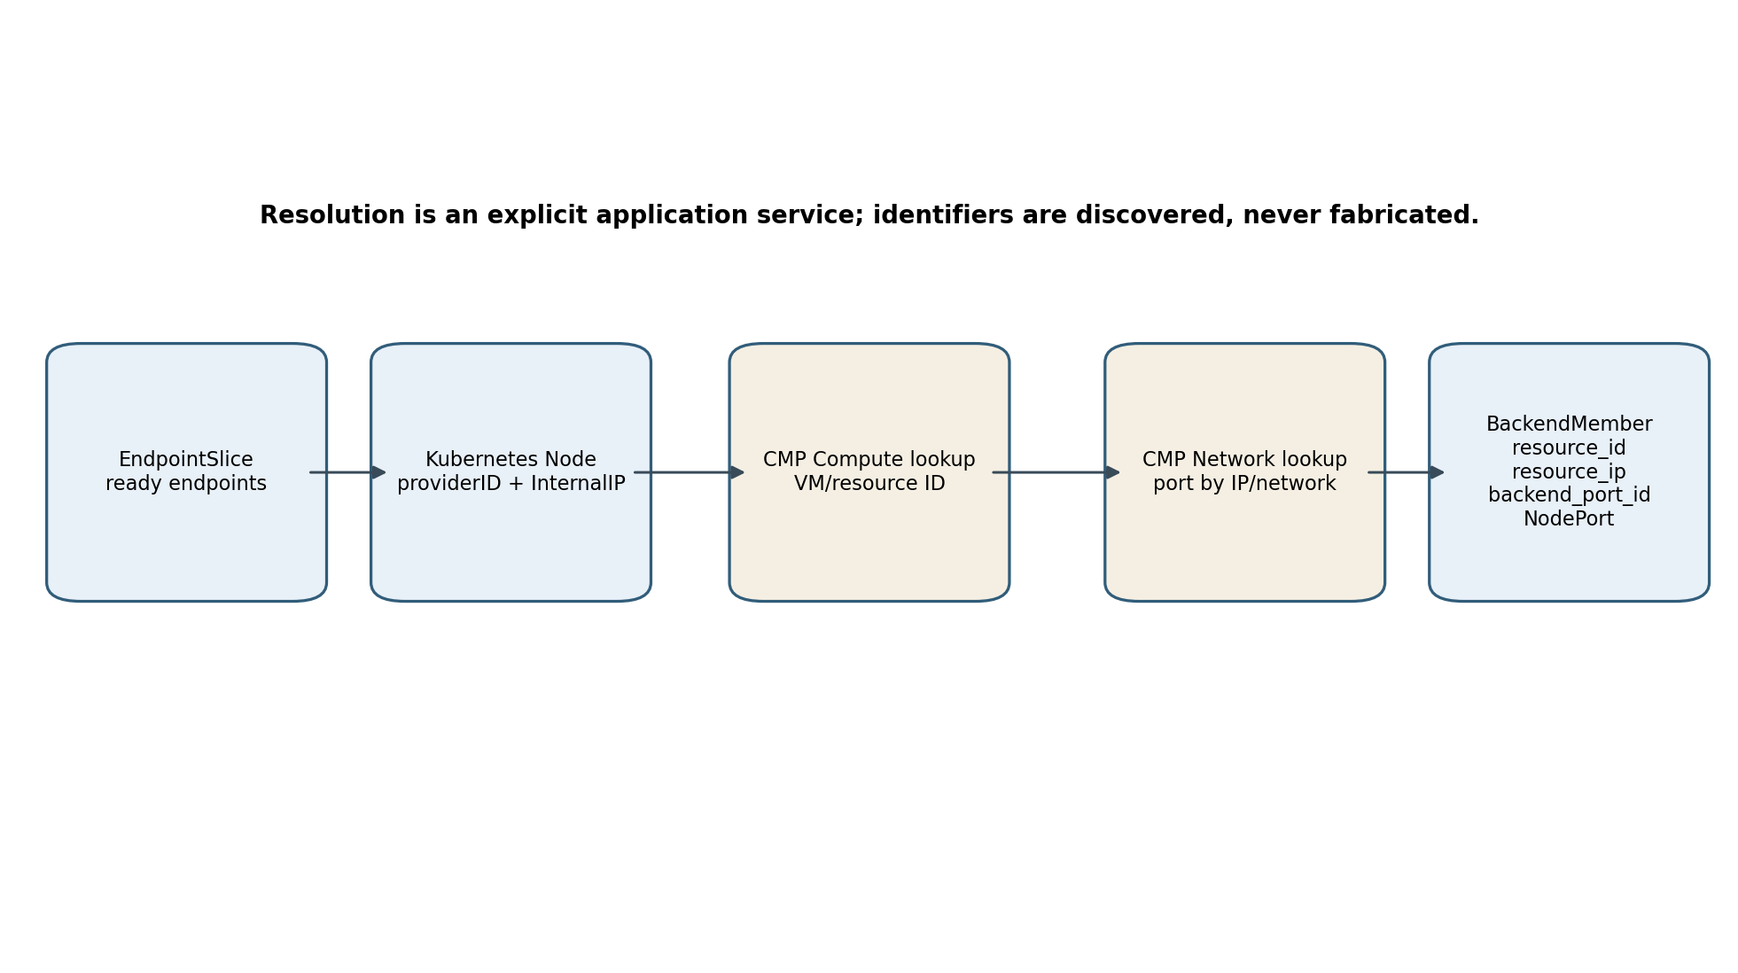
Figure 2-7. Node to CMP backend identity resolution

12.1 Resolution input and output
type BackendCandidate struct {
NodeName string
NodeUID types.UID
InternalIP net.IP
ProviderID string
NodePort int32
ReadyEndpoints int
}
type ResolvedBackend struct {
ResourceID string
ResourceType string
ResourceIP string
BackendPortID string
Port int32
Weight int32
}

12.2 Resolution algorithm
1. Read ready EndpointSlice endpoints for the backend Service.
2. Map endpoint.nodeName to Node and apply readiness/traffic-policy eligibility.
3. Select Node InternalIP and parse providerID when present.
4. Query CMP compute inventory to resolve authoritative VM/resource ID.
5. Query CMP network port search-by-IP or network port inventory.
6. Require exactly one eligible port in the configured Shoot network.
7. Construct ResolvedBackend with provider-returned IDs and NodePort.
8. Cache positive immutable mappings for a bounded period; invalidate on Node/network changes.

12.3 Ambiguity and safety rules
- Zero matching VM or port is a dependency-resolution error; no placeholder member is created.
- Multiple matching ports are rejected unless network/project constraints reduce the result to one.
- The resolved port must belong to the configured organization, project and network.
- A member deletion removes pool membership only. It never invokes compute or port deletion APIs.
- Backend weight calculation is a builder policy; API serialization is a client concern.

13. Ownership, Discovery and Adoption
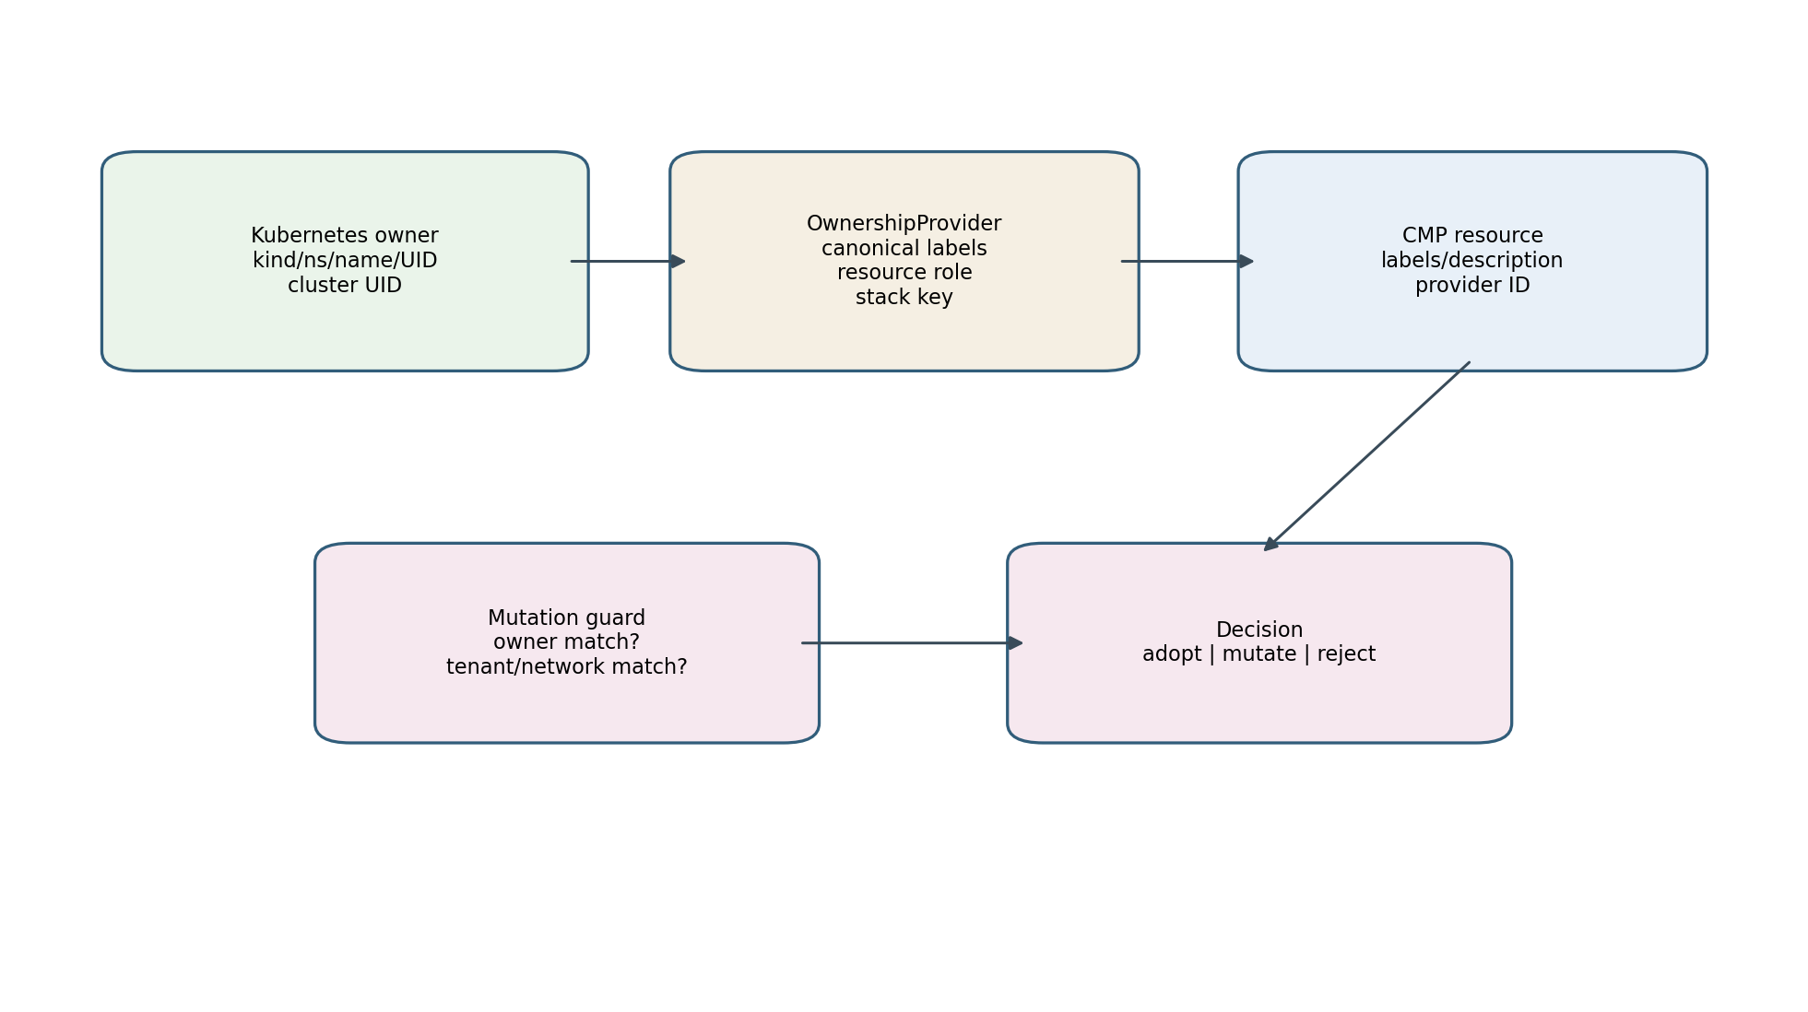
Figure 2-8. Ownership creation and mutation guard

13.1 Ownership schema
Field | Purpose
managed-by | Stable controller identity
cluster-uid | Shoot/cluster isolation
source-kind | Service, IngressGroup or future Gateway
source-namespace/name | Human diagnostics
source-uid | Prevents accidental adoption after name reuse
stack-key | Groups related provider objects
resource-role | lb-service, vip, virtual-server, pool, member, monitor, rule, certificate
shared-group | Explicit shared frontend identity when enabled
model-version | Allows controlled evolution of naming/model semantics

13.2 Discovery hierarchy
1. Use known external ID when available, then verify ownership.
2. List/filter by CMP labels where the API supports it.
3. Fall back to deterministic name plus full ownership verification.
4. Never mutate or delete a name match with absent/conflicting ownership.

13.3 Adoption policy
Observed resource | Action
Exact ownership match and compatible scope | Adopt/reconcile
Same source UID but older model version | Adopt through explicit migration rule
Same name, no ownership | Reject and surface conflict
Different source UID | Do not adopt; preserve resource
Owned but absent from desired | Delete in dependency-safe cleanup

14. Finalizer Architecture

14.1 Service finalizer
The Service finalizer is added before any provider create. On deletion or claim loss, the controller deploys an empty stack for that ownership scope, verifies required external resources are absent, removes generated Kubernetes objects, then removes the finalizer.

14.2 Ingress group finalizers
Ingress cleanup is group-aware. Active members retain the group frontend. Inactive members may have their finalizer removed only after resources owned exclusively by those members are absent and shared group resources remain correctly referenced by active members.

14.3 Finalizer invariants
- A provider API timeout never causes finalizer removal.
- A 404 counts as absent only for the exact scoped resource.
- Ownership conflicts block destructive cleanup and produce an operator-visible event.
- Emergency force-removal is an operational procedure outside normal reconciliation and must be audited.

15. Validation Pipeline
Stage | Examples | Output
Claim validation | class/loadBalancerClass, namespace policy | claimed or ignored
Kubernetes shape | ports, protocols, backend references, path types | typed normalized input
Feature compatibility | shared VIP, TLS, persistence, health monitors | supported or explicit permanent error
Provider context | organization, project, network, flavor | validated provider scope
Cross-resource validation | unique frontend tuples; route priority; compatible pool action | complete build plan
Resolved identity validation | VM and port belong to expected network | safe backend members
Validation errors are user-facing and stable. They include field paths and supported alternatives. Provider calls are not made for a model that fails validation, except read-only capability or identity checks required to validate it.

16. Resource Lifecycle State Model
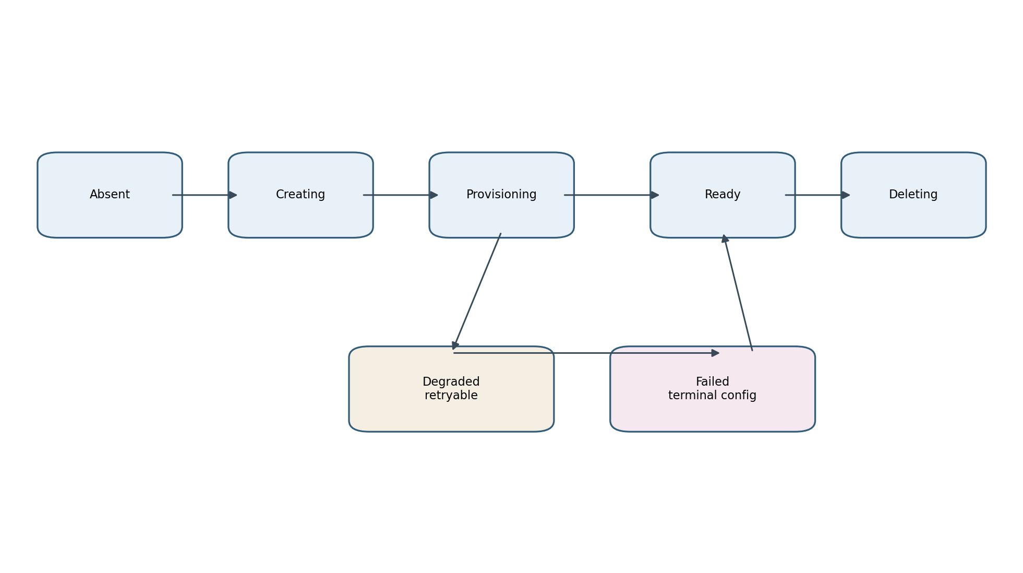
Figure 2-9. Provider resource lifecycle state model
State | Meaning | Controller action
Absent | No owned provider object | Create when desired
Creating | Create accepted; identity may or may not be returned | Rediscover/poll with bounded interval
Provisioning | Object exists but not ready | Do not publish dependent readiness
Ready | Desired and observed are converged | NoOp; publish status
Degraded | Retryable provider/dependency failure | Retry with classified backoff
Failed | Permanent desired configuration/provider rejection | Event and wait for desired change
Deleting | Delete accepted; object still visible | Poll until absent

17. Typed CMP Client Architecture

17.1 Client boundaries
Client | Representative operations
LBServiceClient | List/Get/Create/Delete LB services; labels
VIPClient | List/Create/Delete VIP; obtain allocated address
VirtualServerClient | List/Get/Create/Patch/Delete; health check
PoolClient | Create/Get/Delete; set default
MemberClient | Create/Update/Delete; administrative state; health
MonitorClient | List/Create/Update/Patch/Delete
RoutingRuleClient | List/Create/Delete rules
CertificateClient | Upload/list/delete and attach to LB/virtual server
ComputeClient | Resolve VM/resource by provider identity or IP
NetworkClient | Search port by IP; get port/network metadata

17.2 Transport contract
- All methods accept context and honor cancellation/timeouts.
- Authentication token acquisition/refresh is isolated from resource clients.
- Requests and responses use generated or hand-maintained typed DTOs; raw map[string]any does not escape the client package.
- HTTP status, provider error body, request ID and retry hints are converted to typed errors.
- Sensitive headers and certificate material are redacted from logs.
- Retries at transport level are limited to safe idempotent operations or requests with a provider-supported idempotency key.
type APIError struct {
Operation string
StatusCode int
RequestID string
RetryAfter time.Duration
Category ErrorCategory
Message string
}

18. Status, Conditions, Events and Readiness
Output | Rule
Service.status.loadBalancer.ingress | Write allocated VIP after frontend readiness gate
Ingress.status.loadBalancer.ingress | Write group VIP after required HTTP/HTTPS frontends are ready
Events | Emit accepted/provisioning/ready and actionable failures, rate-limited
Conditions | Use extension-owned condition surface only if a suitable API exists; otherwise Events and metrics
Observed IDs | Store only as optimization hints in a controlled annotation/status object if required; always verify ownership

18.1 Recommended readiness gate
A frontend is ready when the LB Service, VIP and required Virtual Server are provider-ready, and each required default/routed pool exists. Backend health may be reported as degraded rather than blocking VIP publication, because an application can temporarily have zero ready endpoints. This policy is finalized per Service and Ingress semantics in Parts 3 and 4.

19. Concurrency, Idempotency and Restart Recovery
- Leader election ensures one active mutating controller instance per Shoot.
- Per-key controller-runtime serialization is relied upon, but provider operations remain idempotent because duplicate events and failover can occur.
- Create-time uncertainty is handled by rediscovery through ownership before issuing another create.
- No correctness-critical state exists only in memory.
- Logical IDs and ownership survive restarts; external IDs are rediscovered.
- Status writes use merge/optimistic patches and do not overwrite unrelated fields.
- Caches improve performance but may be discarded without changing correctness.

20. Package Architecture
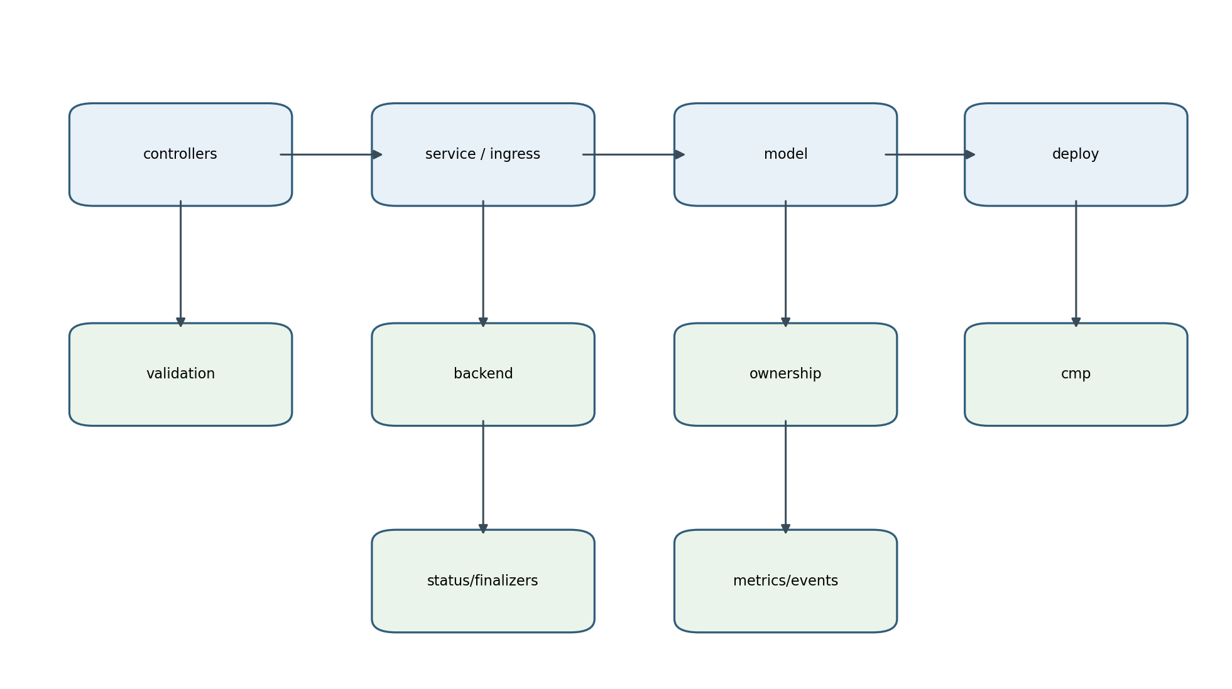
Figure 2-10. Proposed package dependency structure
Package | Contents
cmd/controller-manager | flags, configuration, dependency wiring, manager start
controllers/service | Service reconciler and event mapping
controllers/ingress | Ingress-group reconciler and event mapping
pkg/service | Service normalized input and model builder
pkg/ingress | Ingress grouping, normalized input and model builder
pkg/model | provider-independent internal graph and resource specs
pkg/deploy | stack deployer, planner, bindings and manager interfaces
pkg/deploy/lbservice etc. | resource-specific CMP reconciliation managers
pkg/cmp | typed clients, DTOs, auth, transport and errors
pkg/backend | EndpointSlice/node selection and CMP identity resolution
pkg/validation | shared and feature-specific validation
pkg/ownership | ownership envelope, naming, discovery filters
pkg/finalizers | Service and group finalizer helpers
pkg/status | Service/Ingress patch writers
pkg/metrics and pkg/events | observability contracts

20.1 Dependency rules
controllers -> service/ingress builders, deploy, status, finalizers
service/ingress -> model, validation, backend, ownership
deploy -> model, cmp, ownership
backend -> Kubernetes readers + compute/network clients
cmp -> transport/auth only
model -> no Kubernetes clients and no CMP clients

21. Key Go Interfaces
type ServiceModelBuilder interface {
Build(ctx context.Context, svc *corev1.Service) (model.Stack, BuildResult, error)
}
type IngressModelBuilder interface {
Build(ctx context.Context, group IngressGroup) (model.Stack, BuildResult, error)
}
type BackendResolver interface {
Resolve(ctx context.Context, request BackendResolutionRequest) ([]ResolvedBackend, error)
}
type OwnershipProvider interface {
ForObject(cluster ClusterIdentity, obj client.Object, role model.ResourceRole, stackKey string) model.Ownership
Matches(expected model.Ownership, observed cmp.Labels) bool
}
type StatusWriter interface {
WriteService(ctx context.Context, svc *corev1.Service, obs FrontendObservation) error
WriteIngresses(ctx context.Context, group IngressGroup, obs FrontendObservation) error
}

22. Architecture Decision Records
ADR | Decision | Rationale
ADR-02-01 | Use separate Service and Ingress-group reconcilers | Ownership, watch graph and semantics differ
ADR-02-02 | Build a complete internal stack before mutation | Enables validation, deterministic diff, testing and shared deployment
ADR-02-03 | Use resource-specific deployment managers | CMP resources have different endpoints, dependencies and mutability
ADR-02-04 | Use node/VM plus NodePort target mode initially | Matches CMP member identity needs and current reachable network model
ADR-02-05 | Make ownership first-class | Safe adoption, update and deletion cannot rely on names
ADR-02-06 | Do not persist internal model as CRDs | Kubernetes intent and CMP state are sufficient sources of truth
ADR-02-07 | Treat current F5 code as integration reference only | Avoid inheriting unverified architecture
ADR-02-08 | Use asynchronous readiness rather than synchronous long polling | Keeps reconciliation bounded and resilient
ADR-02-09 | Share deployment/client foundations between Service and Ingress | Same provider resource hierarchy; avoids divergent behavior
ADR-02-10 | Introduce shared VIP only through explicit group identity | Prevents accidental cross-owner coupling and unsafe deletion

23. Implementation Boundaries for Incremental Delivery
The target architecture does not require a big-bang rewrite. It should be introduced through small vertical slices while preserving working CMP integration.
Slice | Deliverable | Exit criterion
1 | Typed ownership and naming package | Unit-tested canonical metadata and matching
2 | Typed CMP client facade around existing HTTP integration | No controller uses raw HTTP/JSON
3 | Internal model primitives and LBService/VIP manager | Create/read/delete idempotency verified
4 | Backend resolver with compute/network port lookup | Node -> VM -> backend_port_id integration test
5 | Service model builder for one TCP port | Desired stack unit tests
6 | Stack deployer and Service controller integration | Single-port Service converges and cleans up
7 | Pool/member diff; multi-port support | Scale and node replacement do not recreate frontend
8 | Ingress builder and routing rules | Host/path routing verified against CMP
9 | Certificates, monitors and advanced policy | Capability-gated features
10 | Migration/adoption and production hardening | Restart, duplicate event, partial failure and HA tests

24. Design Invariants
1. A controller restart does not lose ownership or require in-memory recovery state.
2. No CMP resource is mutated or deleted unless ownership and provider scope are verified.
3. Backend resource IDs and backend_port_id values are returned by CMP lookup APIs, never synthesized.
4. A member removal cannot delete a VM or network port.
5. An EndpointSlice or node change reconciles members without recreating unchanged VIPs or Virtual Servers.
6. Service and Ingress builders share model/deployment contracts but not Kubernetes-specific semantics.
7. Raw CMP JSON and HTTP status handling remain inside pkg/cmp.
8. A finalizer is removed only after mandatory owned external resources are verified absent.
9. Logical IDs are deterministic and independent from provider-generated IDs.
10. Unsupported Kubernetes semantics fail explicitly before provider mutation.
11. Every provider call is context-bound, time-limited and observable.
12. The desired-state model remains acyclic and complete for the reconciliation key.

25. Part 2 Completion and Handoff
This document establishes the fixed component and internal-model foundation. Part 3 applies these contracts to the complete Service type=LoadBalancer design, including claim rules, port expansion, traffic policy, endpoint/node eligibility, backend weighting, status publication, update behavior, deletion, and Service-specific sequence/activity diagrams. Part 4 then applies the same architecture to Ingress grouping, routing rules and TLS.

Appendix A - CMP Endpoint Mapping Used by the Architecture
Model resource | CMP endpoint pattern
LB Service | /load-balancers/.../load-balancers/lb_service/
VIP | .../lb_service/{lb_service_id}/vip
Virtual Server | .../load-balancers/{lb_service_id}/virtual-servers
Routing Rule | .../lb_service/{lb_service_id}/virtual-servers/{virtual_server_id}/routing-rules
Pool | .../virtual-servers/{virtual_server_id}/pools
Member | .../pools/{virtual_server_pool_id}/members
Monitor | .../pools/{virtual_server_pool_id}/monitors
Default pool | .../pools/{virtual_server_pool_id}/set-default
Virtual-server certificates | .../virtual-servers/{virtual_server_id}/certificates/
Network port lookup | /networks/.../networks/ports/search-by-ip/ and network port inventory
Certificate inventory | /certificates/domain/{organization_id}/project/{project_id}/certificates/

Appendix B - Traceability to Previous LLD
The following valid concepts from the previous LLD are retained and refined: thin controllers, builders, desired-state graph, typed clients, ownership, finalizers, backend selection, Node-to-VM mapping, backend_port_id, LB Service, VIP, Virtual Server, pools, members, monitors, routing rules, status, idempotency, deletion ordering, restart recovery, observability, security and incremental implementation. Statements about the correctness or limitations of the current implementation are intentionally excluded from the target design.

